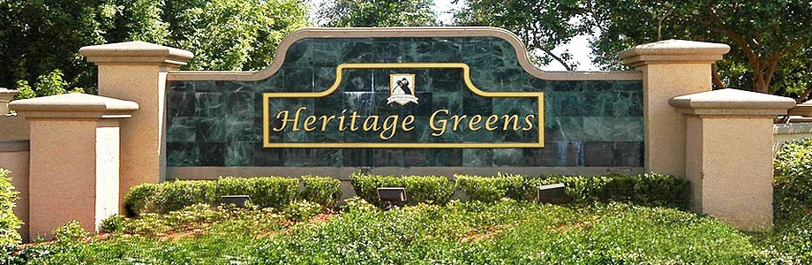Envera Systems will secure & protect Heritage Greens
Beginning early June
RESIDENT meetings

Envera will be at your community to provide training on the new Virtual Gate Guard Kiosk System and answer any questions regarding the new security along with your community management.

Day | Time | Location
Wednesday, May 22nd | 4:00pm-5:00pm | Onsite Clubhouse
Thursday, May 23rd | 6:30pm-7:30pm | Onsite Clubhouse

A letter will be mailed to all residents prior to the meetings with more important details, including your account login information to www.myenvera.com where you can register temporary and permanent guests for your gate.

